Kubernet Config Map

[root@k-master yamls]# vim 6-configmap-1.yaml

apiVersion: v1

kind: ConfigMap

metadata:

name: demo-configmap

data:

channel.name: "justmeandopensource"

channel.owner: "Venkat Nagappan"

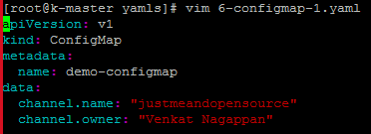

[root@k-master yamls]# kubectl get configmaps

No resources found in default namespace.

[root@k-master yamls]# kubectl get cm

No resources found in default namespace.

[root@k-master yamls]# kubectl create -f 6-configmap-1.yaml

configmap/demo-configmap created

[root@k-master yamls]#

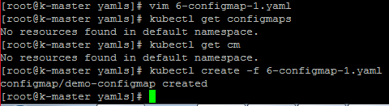

[root@k-master yamls]# kubectl get cm

NAME DATA AGE

demo-configmap 2 43s

[root@k-master yamls]# kubectl get cm -o wide

NAME DATA AGE

demo-configmap 2 50s

[root@k-master yamls]# kubectl describe cm demo-configmap

Name: demo-configmap

Namespace: default

Labels: <none>

Annotations: <none>

Data

====

channel.owner:

----

Venkat Nagappan

channel.name:

----

justmeandopensource

Events: <none>

[root@k-master yamls]#

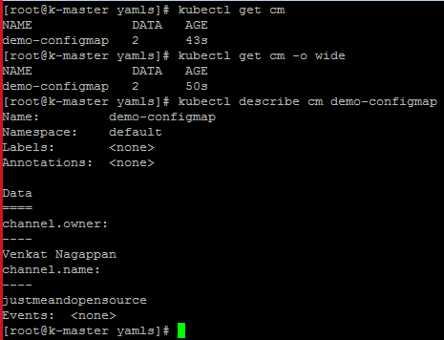

[root@k-master yamls]# kubectl get cm demo-configmap -o yaml

apiVersion: v1

data:

channel.name: justmeandopensource

channel.owner: Venkat Nagappan

kind: ConfigMap

metadata:

creationTimestamp: "2020-07-01T02:07:11Z"

managedFields:

- apiVersion: v1

fieldsType: FieldsV1

fieldsV1:

f:data:

.: {}

f:channel.name: {}

f:channel.owner: {}

manager: kubectl

operation: Update

time: "2020-07-01T02:07:11Z"

name: demo-configmap

namespace: default

resourceVersion: "1835"

selfLink: /api/v1/namespaces/default/configmaps/demo-configmap

uid: b99ef2f9-b90c-4062-a1eb-637a0288d28d

[root@k-master yamls]#

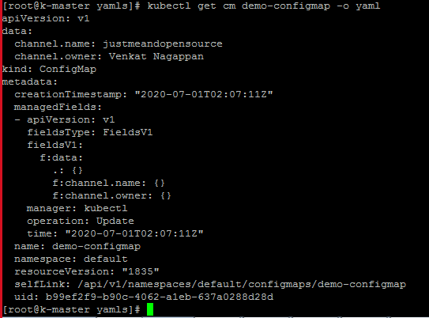

[root@k-master yamls]# **kubectl create configmap demo-config-map-1 --from-literal=channel.name=justopensource --from-literal=channel.owner=sahoo**

configmap/demo-config-map-1 created

[root@k-master yamls]#

[root@k-master yamls]# kubectl get cm

NAME DATA AGE

demo-config-map-1 2 21s

demo-configmap 2 6m43s

[root@k-master yamls]# kubectl get cm demo-config-map-1 -o yaml

apiVersion: v1

data:

channel.name: justopensource

channel.owner: sahoo

kind: ConfigMap

metadata:

creationTimestamp: "2020-07-01T02:13:33Z"

managedFields:

- apiVersion: v1

fieldsType: FieldsV1

fieldsV1:

f:data:

.: {}

f:channel.name: {}

f:channel.owner: {}

manager: kubectl

operation: Update

time: "2020-07-01T02:13:33Z"

name: demo-config-map-1

namespace: default

resourceVersion: "2715"

selfLink: /api/v1/namespaces/default/configmaps/demo-config-map-1

uid: 19c28d32-218f-49ad-ae5e-5a85d3cb8a24

[root@k-master yamls]#

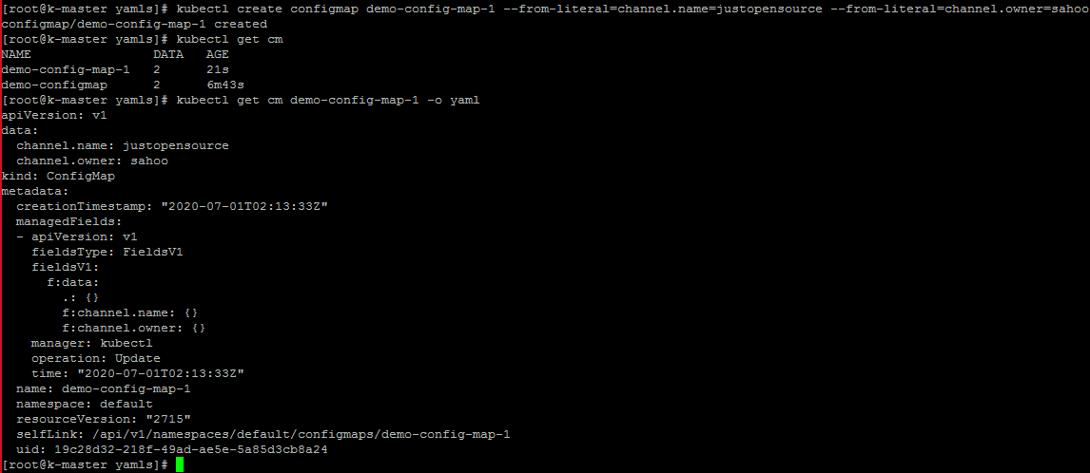

**To create config map inside container**

[root@k-master yamls]# vim 6-pod-configmap-env.yaml

apiVersion: v1

kind: Pod

metadata:

name: busybox

spec:

containers:

- image: busybox

name: busybox

command: ["/bin/sh"]

args: ["-c", "sleep 600"]

env:

- name: CHANNELNAME

valueFrom:

configMapKeyRef:

name: demo-configmap

key: channel.name

- name: CHANNELOWNER

valueFrom:

configMapKeyRef:

name: demo-configmap

key: channel.owner

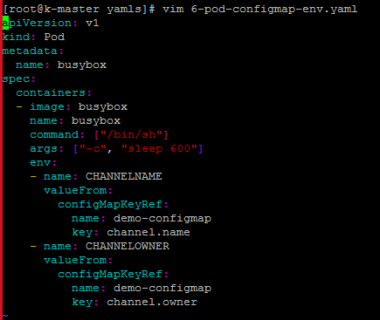

[root@k-master yamls]# kubectl get pods

No resources found in default namespace.

[root@k-master yamls]# kubectl create -f 6-pod-configmap-env.yaml

pod/busybox created

[root@k-master yamls]# kubectl get pods

NAME READY STATUS RESTARTS AGE

busybox 0/1 ContainerCreating 0 3s

[root@k-master yamls]# kubectl get pods

NAME READY STATUS RESTARTS AGE

busybox 1/1 Running 0 10s

[root@k-master yamls]#

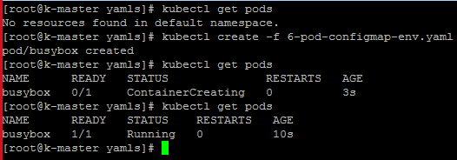

[root@k-master yamls]# kubectl exec -it busybox sh

kubectl exec [POD] [COMMAND] is DEPRECATED and will be removed in a future version. Use kubectl kubectl exec [POD] -- [COMMAND] instead.

/ # echo $CHANNELOWNER

Venkat Nagappan

/ # echo $CHANNELNAME

justmeandopensource

/ # env | grep -i channel

CHANNELOWNER=Venkat Nagappan

CHANNELNAME=justmeandopensource

/ #

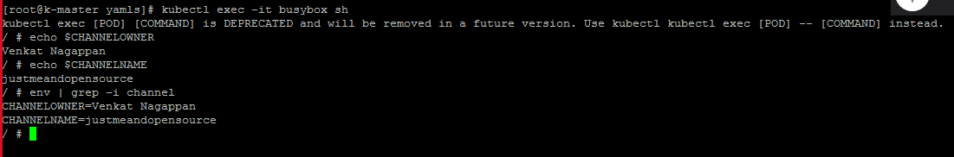

Lets remove exising pod

NAME READY STATUS RESTARTS AGE

busybox 1/1 Running 2 21m

[root@k-master yamls]# kubectl delete pod busybox

pod "busybox" deleted

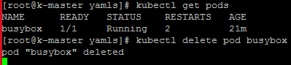

**Lets put config map inside dir of pod**

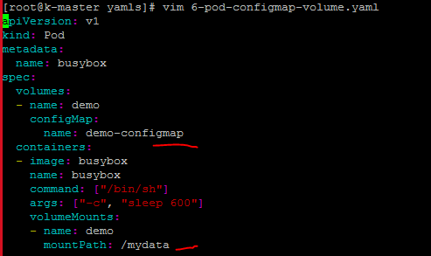

[root@k-master yamls]# kubectl create -f 6-pod-configmap-volume.yaml

pod/busybox created

[root@k-master yamls]# kubectl get pods

NAME READY STATUS RESTARTS AGE

busybox 1/1 Running 0 16s

[root@k-master yamls]# kubectl exec -it busybox sh

kubectl exec [POD] [COMMAND] is DEPRECATED and will be removed in a future version. Use kubectl kubectl exec [POD] -- [COMMAND] instead.

/ # ls -lrt /mydata/

total 0

lrwxrwxrwx 1 root root 20 Jul 1 02:44 channel.owner -> ..data/channel.owner

lrwxrwxrwx 1 root root 19 Jul 1 02:44 channel.name -> ..data/channel.name

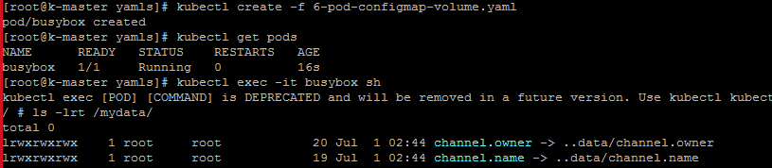

**How to change the keyvalue in cofigmap**

kubectl edit configmap demo-configmap

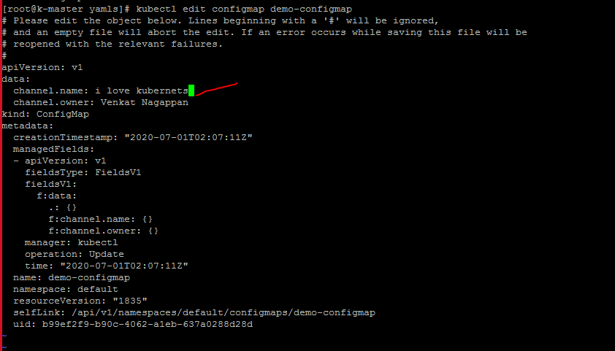

kubectl get configmap demo-configmap -o yaml

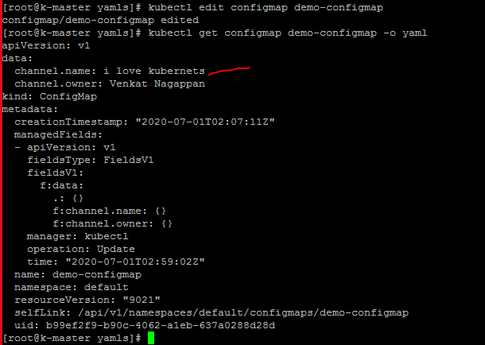

[root@k-master yamls]# kubectl exec -it busybox sh

kubectl exec [POD] [COMMAND] is DEPRECATED and will be removed in a future version. Use kubectl kubectl exec [POD] -- [COMMAND] instead.

/ # ls -lrt /mydata/

total 0

lrwxrwxrwx 1 root root 20 Jul 1 02:44 channel.owner -> ..data/channel.owner

lrwxrwxrwx 1 root root 19 Jul 1 02:44 channel.name -> ..data/channel.name

/ # cat /mydata/channel.owner

/ # cat /mydata/channel.name

i love kubernets/ #

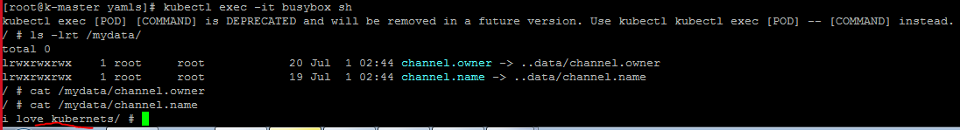

**How to move file inside pod**

[root@k-master yamls]# vim a.ini

[root@k-master yamls]# mv a.ini /tmp/

[root@k-master yamls]# cat /tmp/a.ini

hostname

ambari-agent

port

key

[root@k-master yamls]#

[root@k-master yamls]# kubectl create configmap mysql-demo-config --from-file=/tmp/a.ini

configmap/mysql-demo-config created

[root@k-master yamls]# kubectl get cm

NAME DATA AGE

demo-config-map-1 2 55m

demo-configmap 2 61m

mysql-demo-config 1 77s

[root@k-master yamls]#

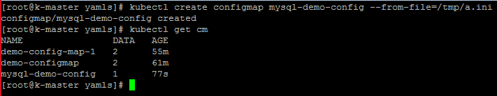

kubectl get configmap mysql-demo-config -o yaml

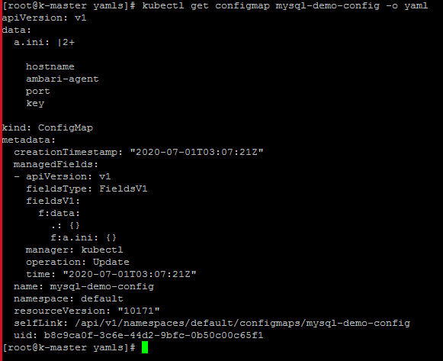

Lets delete existing pod

kubectl delete pod busybox



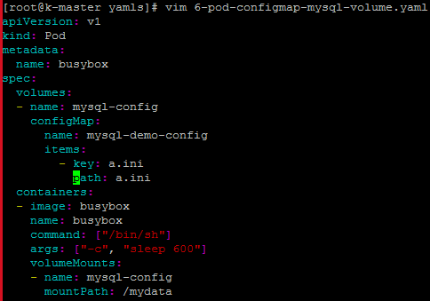

[root@k-master yamls]# kubectl create -f 6-pod-configmap-mysql-volume.yaml

pod/busybox created

[root@k-master yamls]# kubectl get po

NAME READY STATUS RESTARTS AGE

busybox 1/1 Running 0 21s

[root@k-master yamls]# **kubectl exec -it busybox sh**

kubectl exec [POD] [COMMAND] is DEPRECATED and will be removed in a future version. Use kubectl kubectl exec [POD] -- [COMMAND] instead.

/ # **ls** -lrt /mydata/

total 0

lrwxrwxrwx 1 root root 12 Jul 1 03:17 a.ini -> ..data/a.ini

/ # **cat /mydata/a.ini**

hostname

ambari-agent

port

key

